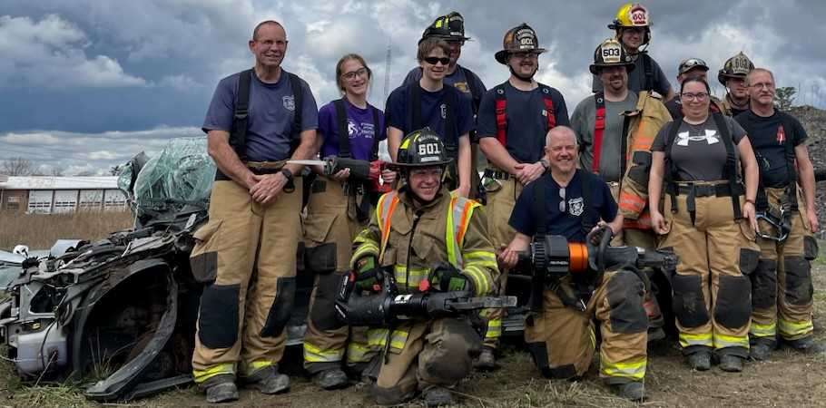
The Perks:
- Free training
- Be part of a TEAM
- Free annual physical
- Free gym membership
- Lifelong camaraderie
- Opportunity to make a difference

- Call (814) 445-4343 or email: sfd@somersetfire.com for an application
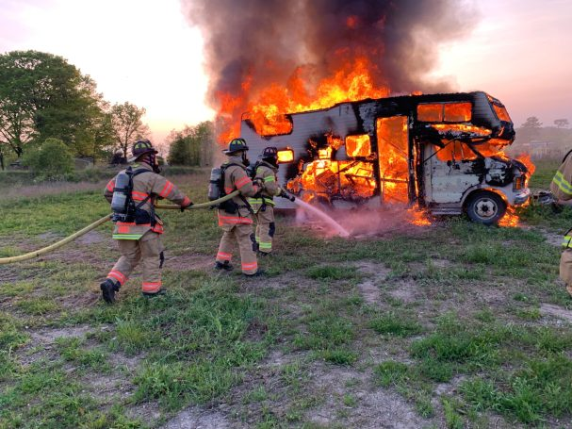

Gear up, get in the action and volunteer today!
- Somerset Fire Department handles over 400 calls every year and is a 100% volunteer department.
- We offer several different types of memberships including active, associate firefighting, associate non firefighting, and junior memberships.
- No matter what your occupation is, you can make a difference in the community. Our current members come from all different backgrounds including: Banker, insurance agent, correction officer, teacher, local business owners, and many more.
What fuels your fire?
- The fire service is a unique and complex business.
- This is your opportunity to get involved in something that is rewarding and meaningful and make a difference in your community.
Can you handle the heat?
Requirements:
- No experience necessary
- Be at least 14 years old
- Good physical health
- No criminal record
- Able to obtain child clearances.

